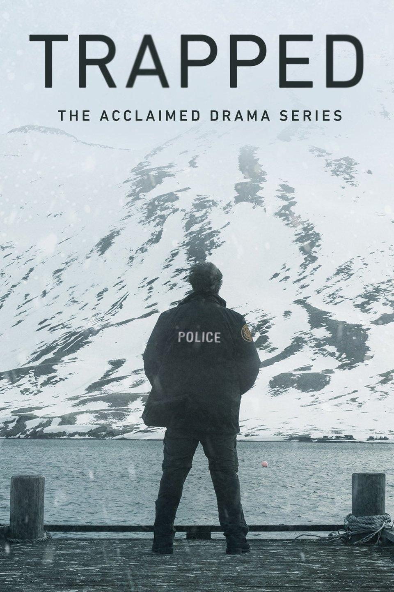
Nygaard building 5335, Room 295, Department of Media Studies Helsingforsgade 12, 8200 Aarhus
Updated 1 October 2018

Following from the research project ‘What Makes Danish TV Drama Travel?’ (FKK 2014-2018), we hope to extend the discussion to a transdisciplinary space and build new collaborative networks and research. There has been a recent interest in Nordic noir, not only within film and television studies, but also within Scandinavian studies and geography. However, there have been very few and sparse collaborations across these different disciplines to date. This workshop attempts to bridge the gap.

Norden’s dramatic television series – from Borgen to The Bridge to Occupied - currently serve as a model for the rest of the world. Shaped by public service broadcasting traditions which are rooted in providing social critique, these programmes provide a rich reservoir of representation of how northern Europe sees itself. With this in mind, the proposed project will investigate the geopolitical implications of the series within and beyond the region. Building on Saunders’ (2017) typology of geopolitical television, we will bring together a group of scholars drawn from multiple disciplines (media studies, screen studies, literature, cross-cultural communication, geography, International Relations, Scandinavian studies ) to examine how Norden’s television series build lifeworlds (Gavins & Lahey, 2016; Tischleder, 2017; Wolf, 2012), and the role that these visually and textually produced imaginaries play in contemporary politics, society, and culture.

Track 1, Re-imagining the North in Nordic Noir, will focus on contemporary audiovisual representations of Norden through the lens of crime drama series, and will also look at changing production cultures related to this milieu. Track 2, Norden’s place in world affairs, will interrogate series that tackle specific aspects of Norden’s place in world affairs, highlighting issues such as national identity (1864), good governance (Borgen), the region’s turn to the right (Blue Eyes), the new Cold War (Occupied), corporate malfeasance (Follow the Money), pandemics (The Rain), military affairs (Nobel), terrorism (The Fourth Man), and indigenous people (Midnight Sun). Beyond such topically-specific series, this workshop will also investigate how Nordic noir crime drama employs geopolitical themes to enhance the genre’s narrative attraction. In Track 3 of the workshop we will unpack the international themes and impact of series such as Forbrydelsen, The Bridge (including its recent Russian-Estonian adaptation, Most), Bordertown, Trapped, The Lava Field, The Look of a Killer, Beck, Wallander, and Dicte. In Track 4, we will explore the visualisation of the region via screened drama, with a specific focus on imaging/imagining the Arctic and the peripheries of ‘the North’. Participants will investigate the ways in which representation of ‘the North’ shape geopolitical codes and visions, particularly in an era where global climate change and rising geopolitics tensions in the Arctic Basin are coming the fore.

The focus of this workshop speaks to two of ReNEW’s research clusters, namely Imagining Norden - Branding and Nordic reputation and Multiculturalism and globalization. Our list of international speakers reflects a transdisciplinary environment wherein we discuss the possibilities to combine, remix, and co-construct theoretical concepts, methodologies, and empirical knowledge from international relations, geopolitics, area studies, television, film, and literature in a Nordic context.
We are also deliberately bringing together a group of scholars who, while working on similar themes, are mostly encountering each other’s work for the first time, in an attempt to challenge and reinvigorate our respective areas of expertise.

At the workshop we hope to lay the foundation for a collection of co-authored journal articles. Prof. Robert A. Saunders will join AU as a Visiting Professor in Fall 2018, where he will potentially organize an interdisciplinary seminar across the departments of Media and Journalism, Scandinavian Studies, and Political Science. Already in progress is the discussion to write a joint application for a European network grant (e.g. COST) and EU H2020 grant based on the new network established via the workshop, which includes researchers from within and outwith the ReNEW hub.

Sources:
Gavins, J., & Lahey, E. (Eds.). (2016). World Building: Discourse in the Mind. London: Bloomsbury.
Saunders, R. A. (2017). Small Screen IR: A Tentative Typology of Geopolitical Television. Geopolitics, DOI: 10.1080/14650045.14652017.11389719.
Tischleder, B. B. (2017). Thickening Seriality: A Chronotopic View of World Building in Contemporary Television Narrative. Velvet Light Trap: A Critical Journal of Film & Television, 79, 120-125.
Wolf, M. J. P. (2012). Building Imaginary Worlds: The Theory and History of Subcreation. New York and London: Routledge.

List of participants:
- Dr Saara Ratilainen, Helsinki University (Literature studies, Russian language and culture)
- Associate Professor, Johannes Riquet, Tampere University (Literature)
- Dr Ekaterina Kalinina, Södertörn University (Baltic studies/Cultural studies)
- Dr Lizaveta Dubinka-Hushcha, Copenhagen Business School (International Economics, Government and Business)
- Dr Jakob Stougaard-Nielsen, UCL (Scandinavian studies)
- Professor Robert Saunders, Farmingdale State College, NY (Geography, IR studies)
- Associate Professor Susanne Eichner, Aarhus University (Media Studies)
- Marie Curie Postdoctoral Fellow Pei Sze Chow, Aarhus University (Media and Scandinavian Studies)
- Associate Professor Kim Toft Hansen, Aalborg University (Nordic Studies)
- Professor Gunhild Agger, Aalborg University (Nordic Studies)
- Assoc. Prof. Anne Marit Waade, Aarhus University (Media Studies)
- Dina Brode-Roger, PhD researcher, KU Leuven (Arctic studies)
- Associate Professor Anna Estera Mrozewicz, Adam Mickiewicz University, Poznań (Scandinavian studies, Film studies)
- Adjunct Professor Jaakko Seppälä, University of Helsinki (Film and Television Studies)
- Associate Professor Pia Majbritt Jensen, Aarhus University (Media Studies)
- Rui Xu, PhD student, Aarhus University (Media Studies)
- Associate Professor Stephen Joyce, Aarhus University (English)
- Nicola Anne Witcombe, Web Manager and Editor for ReNEW, Aarhus University
- Professor Lill-Ann Körber, Aarhus University (Scandinavian Studies)
- Dr Lynge Stegger Gemzøe, Postdoc, Aalborg University (Media Studies)
- Talvi Rouvinen, PhD student, University of Tampere

Nygaard building 5335, Room 295, Department of Media Studies
Helsingforsgade 12, 8200 Aarhus
Programme:
Thursday October 4th
09:30 Coffee, tea
10:00 Welcome & introduction: Robert Saunders, Pei Sze Chow, and Anne Marit Waade
11:00 Re-imagining the North in Nordic Noir, Chair: Robert Saunders
- Gunhild Agger, Aalborg University, DK: Realistic and mythological appropriations: the cases of Shetland and Ø
- Pei Sze Chow, Aarhus University, DK: A Symptom of Something Real: Refracting The Øresund Region in Bron/Broen
- Pia Majbritt Jensen, Aarhus University, DK: Highlights from our audience study reflecting re-imagining the North in Nordic noir
13:00 Lunch (Rooms 295, 297, 298)
13:45 Brainstorm - nordics.info
14:15 Norden’s place in world affairs, Chair: Pei Sze Chow
- Saara Ratilainen, Helsinki University, FI: Russian fans interacting with Nordic television series (the case of Shame)
- Robert Saunders, Farmingdale State College, USA: Why Norden? Why Now? - Nordic Noir, (Geo)politics, and Neoliberalism
- Kim Toft Hansen, Aalborg University, DK: From Nordvision to Eurovision – Nordic Noir, Euronoir and the European Crisis
16:15 Break
16:30 Perspectives, Chair: Anne Marit Waade
- Jakob Stougaard-Nielsen (University College London, UK): Branding Nordic Noir as British Boreal Nostalgia
- Lizaveta Dubinka-Hushcha (Copenhagen Business School, DK): The evolution of Danish public diplomacy and challenges of nation branding
- Future collaboration: network, research, Nordicom Review
19:00 Dinner at Restaurant L’Estragon, Klostergade 6, 8000 Aarhus

Friday October 5th
09:00 Coffee, tea
09:30 Eco-Imaging/imagining the Arctic and Northern Peripheries, Chair: Saara Ratilainen
- Dina Brode-Roger, KU Leuven, BE: Fortitude: Examining Arctic imaginaries in Nordic Noir
- Anna Estera Mrozewicz, Adam Mickiewicz University, Poznań, PL: Reimagining Nordic eco-exceptionalism in the television series Occupied
- Anne Marit Waade, Aarhus University, DK: Arctic utopia in Nordic noir
- Johannes Riquet, Tampere University, FI: Cold Bodies: The Geopolitics of Ice in Recent Arctic Cinema
12:00 Lunch (Rooms 295, 297, 298)
13:00 International themes and impact of series, Chair: Kim Toft Hansen
- Jaakko Seppälä, University of Helsinki, FI: Style and Meaning in Nordic Noir: Reimagining the Welfare States
- Susanne Eichner, Aarhus University, DK: Nordic trends and European Television drama
- Ekaterina Kalinina, Södertörn University, SE: Most: Imagining Nordicness from across the bridge
15:00 Wrap up, what’s next
16:00 End

See http://danishtvdrama.au.dk and http://conferences.au.dk/transnationaltelevisiondrama2018/ for details of the recent conference at Aarhus University.

